AI tools are used in the python or pandas

There re many tools that we can use for the code inbuilt examples. These are the hints for the programmer, because fopr the programmer its not easy to remember the codes. So if we install the small extention modules in the python we can use it anywhere for the hint.

The below window is showing the Github Copilot module and this is installed from the view, extension and search the Github Copilot and the install after initialization of this module we should connect with out github account at the web. Then it works properly.

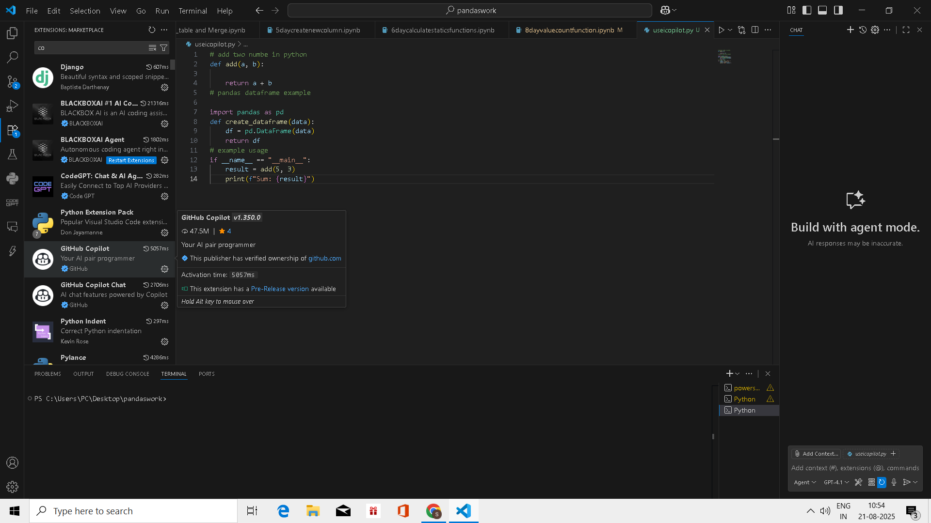

There are so many modules

Like

Blackbox

Chat GPT

Github Copilot

Tabnine

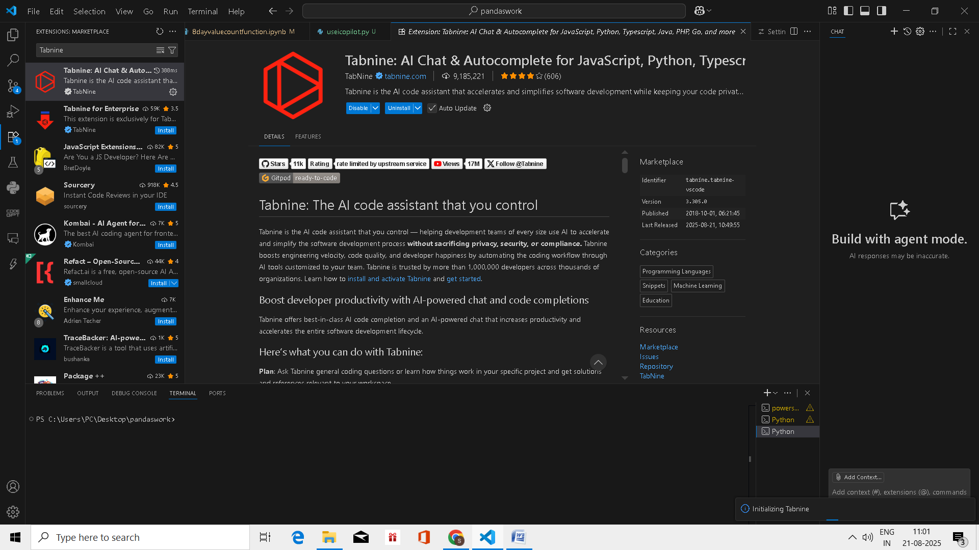

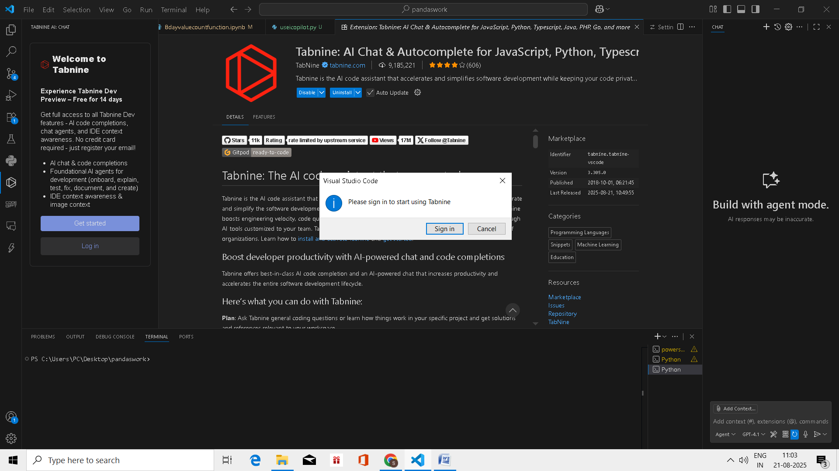

If there is no account then we can create account with my own email id

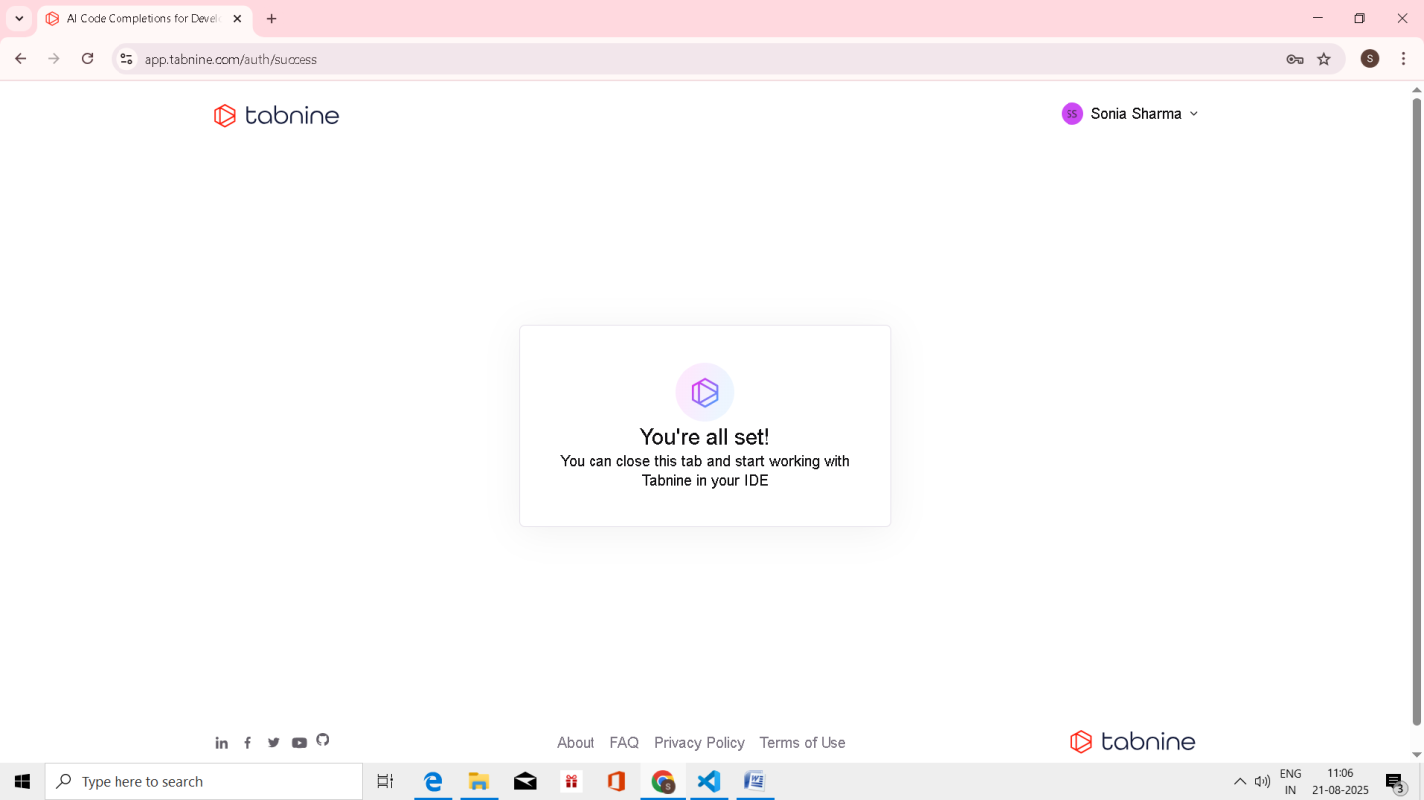

Done